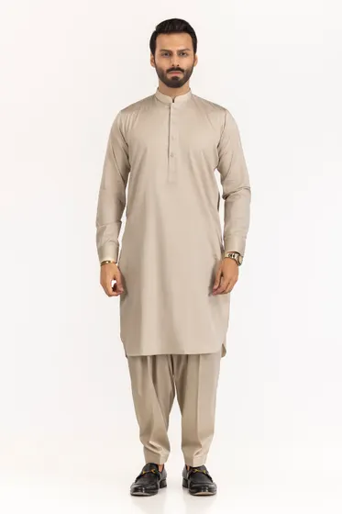[**PRODUCT DETAILS**](https://www.gulahmedshop.com/hitex-satin-plus-unstitched-fabric-cotton#description)

Craft your wardrobe of essentials with the finest fabrics of GulAhmed Men’s Collection.

* Premium Fine Quality 100% Cotton Fabric
* 4.5 MTR Suit Width 55 in With Inlay Collection

|  |  |
| --- | --- |
| More Information | |
| **COLOR:** | Green |
| **NEW ARRIVALS:** | No |
| **GENDER:** | Men |
| **DISCOUNT PERCENTAGE:** | 31% to 40% |
| **SHIRT FABRIC:** | Cotton |

Hitex Satin Plus Unstitched Fabric Cotton

SKU

MEN-FABRIC-303112 -P

IN STOCK

PKR 5,517